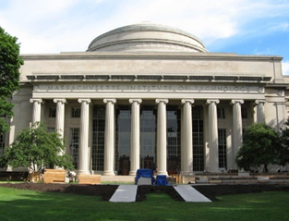
RMW18

The 18th Workshop on Reactive Metal Processing
March 28 (Fri.) – 29 (Sat.), 2025 @ Boston/Cambridge
(After TMS 2025, March 23 (Sun.) – 27 (Thu.), 2025 @ Las Vegas, Nevada)

Organizers:
Donald R. Sadoway, Massachusetts Institute of Technology
Toru H. Okabe, Institute of Industrial Science (IIS),
The University of Tokyo
Antoine Allanore, Massachusetts Institute of Technology
Shunsuke Yagi IIS, The University of Tokyo

Program Coordinators:
Takanari Ouchi, IIS, The University of Tokyo
Gen Kamimura, Massachusetts Institute of Technology
Kai Shimada, IIS, The University of Tokyo
Gavin Winter Massachusetts Institute of Technology

Sponsors
- The Rare Metal Research Workshop, one of the Special Research Groups organized by the Foundation for the Promotion of Industrial Science (FPIS)
(RC-40: directed by Prof. T. H. Okabe, RC-104: directed by Prof. S. Yagi)
- Integrated Research Center for Sustainable Energy and Materials (SUSMAT)
- Institute of Industrial Science, The University of Tokyo (IIS UTokyo SYMPOSIUM No.123)
http://www.okabe.iis.u-tokyo.ac.jp/core-to-core/rmw

